Exam E

QUESTION 1

View the Exhibit and examine the structure of the PROMOTIONS table.

Examine the following two SQL statements:

Statement 1

SQL>SELECT promo_category,SUM(promo_cost)
FROM promotions
WHERE promo_end_date-promo_begin_date > 30
GROUP BY promo_category;

Statement 2

SQL>SELECT promo_category,sum(promo_cost)
FROM promotions
GROUP BY promo_category
HAVING MIN(promo_end_date-promo_begin_date)>30;

Which statement is true regarding the above two SQL statements?

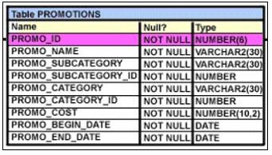

A. | statement 1 gives an error, statement 2 executes successfully
B. | statement 2 gives an error, statement 1 executes successfully
C. | statement 1 and statement 2 execute successfully and give the same output
D. | statement 1 and statement 2 execute successfully and give a different output

QUESTION 2
The following data exists in the PRODUCTS table:

PROD_ID PROD_LIST_PRICE
------------------------------------------------
123456 152525.99

You issue the following query:

SQL> SELECT RPAD((ROUND(prod_list_price)), 10,'*')
FROM products
WHERE prod_id = 123456;

What would be the outcome?

A. | 152526****
B. | **152525.99
C. | 152525**
D. | an error message

QUESTION 3
Examine the structure and data of the CUST_TRANS table:

CUST_TRANS

Name Null? Type
-------- ------- ---------

CUSTNO NOT NULL CHAR(2)

TRANSDATE DATE

TRANSAMT NUMBER(6,2)

CUSTNO TRANSDATE TRANSAMT
------------ ---------------- ---------------
11 01-JAN-07 1000
22 01-FEB-07 2000
33 01-MAR-07 3000

Dates are stored in the default date format dd-mon-rr in the CUST_TRANS table.

Which three SQL statements would execute successfully? (Choose three.)

A. | SELECT transdate + '10' FROM cust_trans;
B. | SELECT * FROM cust_trans WHERE transdate = '01-01-07';
C. | SELECT transamt FROM cust_trans WHERE custno > '11';
D. | SELECT * FROM cust_trans WHERE transdate='01-JANUARY-07';
E. | SELECT custno + 'A' FROM cust_trans WHERE transamt > 2000;

QUESTION 4

View the Exhibit and examine the structure of the PROMOTIONS table.

You have to generate a report that displays the promo name and start date for all promos that started after the last promo in the 'INTERNET' category.

Which query would give you the required output?

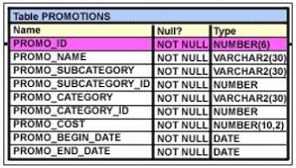

A. | SELECT promo_name, promo_begin_date FROM promotions  WHERE promo_begin_date > ALL (SELECT MAX(promo_begin_date) FROM promotions )AND  promo_category = 'INTERNET';
B. | SELECT promo_name, promo_begin_date FROM promotions  WHERE promo_begin_date IN (SELECT promo_begin_date  FROM promotions  WHERE promo_category='INTERNET');
C. | SELECT promo_name, promo_begin_date FROM promotions  WHERE promo_begin_date > ALL (SELECT promo_begin_date  FROM promotions  WHERE promo_category = 'INTERNET');
D. | SELECT promo_name, promo_begin_date FROM promotions  WHERE promo_begin_date > ANY (SELECT promo_begin_date  FROM promotions  WHERE promo_category = 'INTERNET');

QUESTION 5

View the Exhibit and examine the structure of the PRODUCTS table.

Evaluate the following query:

SQL> SELECT prod_name
FROM products
WHERE prod_id IN (SELECT prod_id FROM products
WHERE prod_list_price =
(SELECT MAX(prod_list_price)FROM products
WHERE prod_list_price <
(SELECT MAX(prod_list_price)FROM products)));

What would be the outcome of executing the above SQL statement?

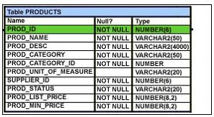

A. | It produces an error.
B. | It shows the names of all products in the table.
C. | It shows the names of products whose list price is the second highest in the table.
D. | It shows the names of all products whose list price is less than the maximum list price.

QUESTION 6

View the Exhibit and examine the data in the COSTS table.

You need to generate a report that displays the IDs of all products in the COSTS table whose unit price is at least 25% more than the unit cost. The details should be displayed in the descending order of 25% of the unit cost.

You issue the following query:

SQL>SELECT prod_id
FROM costs
WHERE unit_price >= unit_cost * 1.25
ORDER BY unit_cost * 0.25 DESC;

Which statement is true regarding the above query?

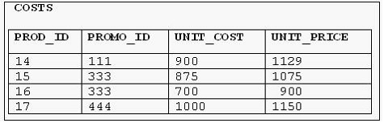

A. | It executes and produces the required result.
B. | It produces an error because an expression cannot be used in the ORDER BY clause.
C. | It produces an error because the DESC option cannot be used with an expression in the ORDER BY clause.
D. | It produces an error because the expression in the ORDER BY clause should also be specified  in the SELECT clause.

QUESTION 7

Which three tasks can be performed using SQL functions built into Oracle Database? (Choose three.)

A. | displaying a date in a nondefault format
B. | finding the number of characters in an expression
C. | substituting a character string in a text expression with a specified string
D. | combining more than two columns or expressions into a single column in the output

QUESTION 8

View the Exhibit and evaluate the structure and data in the CUST_STATUS table.

You issue the following SQL statement:

SQL> SELECT custno, NVL2(NULLIF(amt_spent, credit_limit), 0, 1000)"BONUS" FROM cust_status;

Which statement is true regarding the execution of the above query?

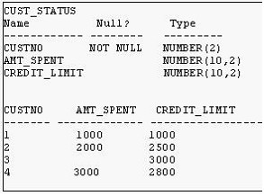

A. | It produces an error because the AMT_SPENT column contains a null value.
B. | It displays a bonus of 1000 for all customers whose AMT_SPENT is less than CREDIT_LIMIT.
C. | It displays a bonus of 1000 for all customers whose AMT_SPENT equals CREDIT_LIMIT, or AMT_SPENT is null.
D. | It produces an error because the TO_NUMBER function must be used to convert the result of the NULLIF function before it can be used by the NVL2 function.

QUESTION 9

Which two statements are true regarding subqueries? (Choose two.)

A. | A subquery can retrieve zero or more rows.
B. | Only two subqueries can be placed at one level.
C. | A subquery can be used only in SQL query statements.
D. | A subquery can appear on either side of a comparison operator.
E. | There is no limit on the number of subquery levels in the WHERE clause of a SELECT statement.

QUESTION 10

View the Exhibit and examine the data in the PRODUCTS table.

You need to display product names from the PRODUCTS table that belong to the 'Software/Other' category with minimum prices as either $2000 or $4000 and no unit of measure.

You issue the following query:

SQL>SELECT prod_name, prod_category, prod_min_price
FROM products
WHERE prod_category LIKE '%Other%' AND (prod_min_price = 2000 OR prod_min_price = 4000) AND prod_unit_of_measure <> '';

Which statement is true regarding the above query?

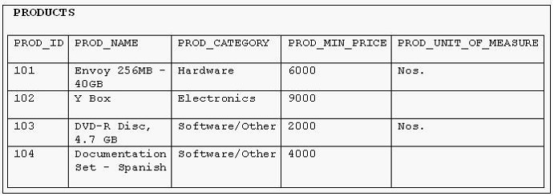

A. | It executes successfully but returns no result.
B. | It executes successfully and returns the required result.
C. | It generates an error because the condition specified for PROD_UNIT_OF_MEASURE is not valid.
D. | It generates an error because the condition specified for the PROD_CATEGORY column is not valid.

QUESTION 11

You need to calculate the number of days from 1st January 2007 till date .

Dates are stored in the default format of dd-mon-rr.

Which two SQL statements would give the required output? (Choose two.)

A. | SELECT SYSDATE - '01-JAN-2007' FROM DUAL;
B. | SELECT SYSDATE - TO_DATE('01/JANUARY/2007') FROM DUAL;
C. | SELECT SYSDATE - TO_DATE('01-JANUARY-2007') FROM DUAL;
D. | SELECT TO_CHAR(SYSDATE, 'DD-MON-YYYY') - '01-JAN-2007' FROM DUAL;
E. | SELECT TO_DATE(SYSDATE, 'DD/MONTH/YYYY') - '01/JANUARY/2007' FROM DUAL;

QUESTION 12
You need to generate a list of all customer last names with their credit limits from the CUSTOMERS table. Those customers who do not have a credit limit should appear last in the list. Which two queries would achieve the required result? (Choose two.)

A. | SELECT cust_last_name, cust_credit_limit  FROM customers  ORDER BY cust_credit_limit DESC;
B. | SELECT cust_last_name, cust_credit_limit  FROM customers  ORDER BY cust_credit_limit;
C. | SELECT cust_last_name, cust_credit_limit  FROM customers  ORDER BY cust_credit_limit NULLS LAST;
D. | SELECT cust_last_name, cust_credit_limit  FROM customers  ORDER BY cust_last_name, cust_credit_limit NULLS LAST;

QUESTION 13

View the Exhibit and examine the structure of the ORD table.

Evaluate the following SQL statements that are executed in a user session in the specified order:

CREATE SEQUENCE ord_seq;

SELECT ord_seq.nextval
FROM dual;

INSERT INTO ord
VALUES (ord_seq.CURRVAL, '25-jan-2007',101);

UPDATE ord
SET ord_no= ord_seq.NEXTVAL
WHERE cust_id =101;

What would be the outcome of the above statements?

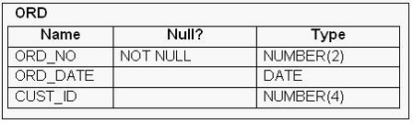

A. | All the statements would execute successfully and the ORD_NO column would contain the value 2  for the CUST_ID 101.
B. | The CREATE SEQUENCE command would not execute because the minimum value  and maximum value for the sequence have not been specified.
C. | The CREATE SEQUENCE command would not execute because the starting value of the sequence  and the increment value have not been specified.
D. | All the statements would execute successfully and the ORD_NO column would have the value 20  for the CUST_ID 101 because the default CACHE value is 20.

QUESTION 14
Examine the structure and data in the PRICE_LIST table:

Name Null? Type
-------------- ---------- ----------------

PROD_ID NOT NULL NUMBER(3)

PROD_PRICE VARCHAR2(10)

PROD_ID PROD_PRICE
------------- -------------------
100 $234.55
101 $6,509.75
102 $1,234

You plan to give a discount of 25% on the product price and need to display the discount amount in the same format as the PROD_PRICE.

Which SQL statement would give the required result?

A. | SELECT TO_CHAR(prod_price* .25,'$99,999.99') FROM PRICE_LIST;
B. | SELECT TO_CHAR(TO_NUMBER(prod_price)* .25,'$99,999.00') FROM PRICE_LIST;
C. | SELECT TO_CHAR(TO_NUMBER(prod_price,'$99,999.99')* .25,'$99,999.00') FROM PRICE_LIST;
D. | SELECT TO_NUMBER(TO_NUMBER(prod_price,'$99,999.99')* .25,'$99,999.00') FROM PRICE_LIST;

QUESTION 15

View the Exhibit for the structure of the STUDENT and FACULTY tables.

You need to display the faculty name followed by the number of students handled by the faculty at the base location. Examine the following two SQL statements:

Statement 1

SQL>SELECT faculty_name,COUNT(student_id)
FROM student JOIN faculty
USING (faculty_id, location_id)
GROUP BY faculty_name;

Statement 2

SQL>SELECT faculty_name,COUNT(student_id)
FROM student NATURAL JOIN faculty
GROUP BY faculty_name;

Which statement is true regarding the outcome?

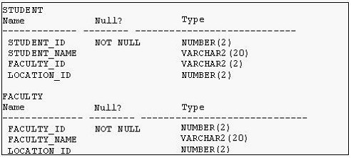

A. | Only statement 1 executes successfully and gives the required result.
B. | Only statement 2 executes successfully and gives the required result.
C. | Both statements 1 and 2 execute successfully and give different results.
D. | Both statements 1 and 2 execute successfully and give the same required result.

